# CIT 171 Lab 4 Introduction to the File System

In this lab, you will explore the Linux file system in order to better understand its fundamental layout. You will experiment with some common file system administration commands.

## Outcomes

* Familiarity with fundamental file system layout
* Familiarity with fundamental file system administration commands
* Practice absolute and relative paths

**CentOS will timeout after a few minutes of inactivity. If this happens to you, click inside of your VM, hit enter, and then simply login again. Your password should be *cit171* if you followed Lab 1’s prompts.**

1. Open a terminal window to access a bash prompt by first clicking **Activities** (top left corner) and then **Terminal.**

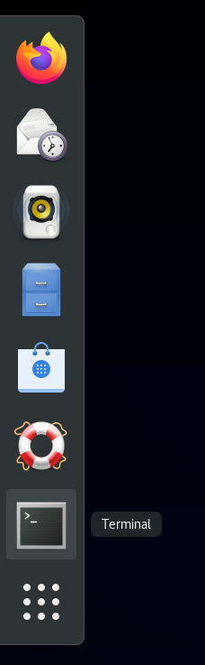

1. Change directories to the root directory, which is denoted by the **/** symbol. Perform a listing to view the subdirectories.

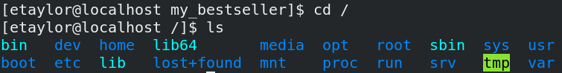

1. Let’s find out more information about the root subdirectories using the **man** command. The **man** command allows you seek help in Linux (typically for a command). It takes one parameter, which is the name of the command/item. It will then retrieve its manual page. Review through line 93 (you will be asked related questions on the lab quiz). Use your up/down arrow key to scroll. Hit the **q** button to exit back to your prompt.

**Command: man hier**

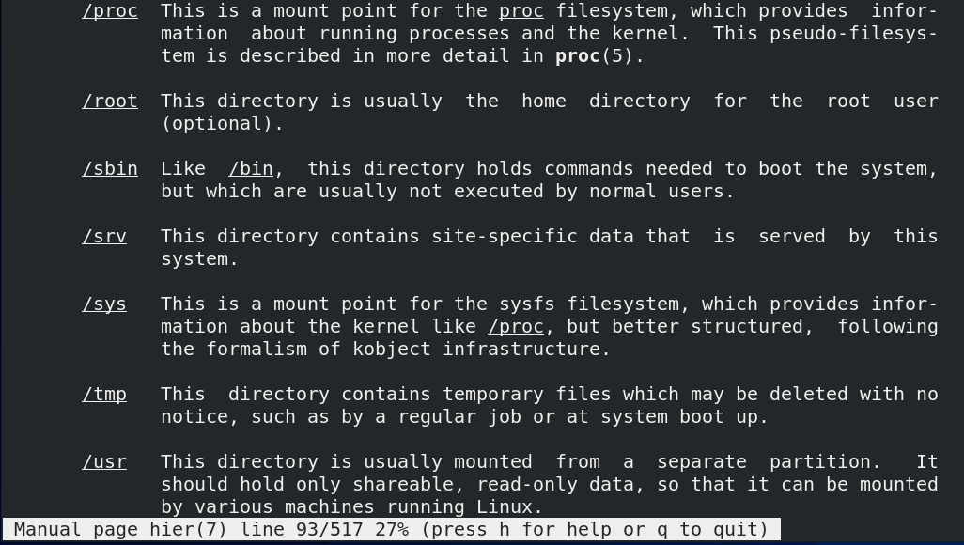

1. Next, we will examine disk file space usage using the **df** command. This command displays the amount of disk space available on all currently mounted file systems. You will be asked questions about this output and **df** in the lab quiz.

**Command: df**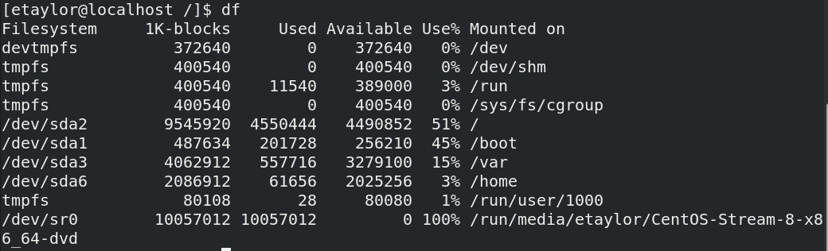

**For the line with /home, take note of /dev/sdaX where X is a number. Mine is /dev/sda6, but your sda number may be different. You need this for step 13.**

1. Open the **man** page for **df**. Reference earlier commands if you need help. Find the required option to *print the file system type*. Modify your **df** command to use this option. **Screenshot your command and its output as part of your lab submission.**
2. Next, let’s explore mounting and unmounting a partition. Mounting in Linux means that you are making a specific filesystem accessible via certain location in the Linux directory tree.   
   **Command: umount /home**



1. Only the root user can mount and unmount partitions. To change to the root user, you will use the **su** command. Without specifying a username, **su** will default to the root user.   
   **Command: su***Your root password should be* ***cit171***

**When typing in your password, it will appear like nothing is being typed into the prompt. No generic characters will be displayed, so type slowly and carefully.**

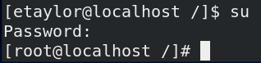

1. Try running the previous **umount** command again. Notice that this time you get a message that the *target* is busy.
2. You can boot to different runtime levels (called targets in newer versions of CentOS), which provide different functionalities (like Safe Mode in the Windows OS). We need to boot to a target that is single-user so that the /home partition is not busy. We are currently running a multi-user target, which means that directories stored under /home are mounted and busy.

You should still be the root user when running the following commands.

**Command: systemctl rescue**

1. The system will restart in rescue mode, taking you away from your command line and GUI environment. You will only have a prompt and you will be unable to use your mouse. If you need to click out of the prompt window, hit **ctrl+alt** on your keyboard to release control back to your host computer. Type in your root password and hit enter. 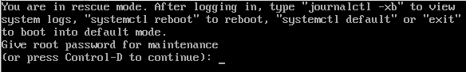
2. Now you can unmount the /home directory. If it is still busy, add the -l option

**Command: umount /home** or **umount -l /home**

1. In the Linux command line, typically “no news is good news” when it comes to running commands. To confirm that your previous command was successful, run the **df** command again. You should not see */home* in the output.  
   **Command: df**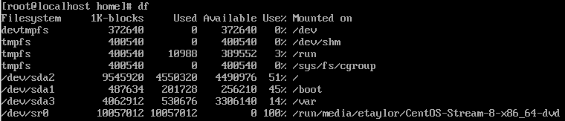
2. Let’s now remount the */home* partition using the **mount** command, which takes two parameters: the device and mountpoint.  
   **Command: mount /dev/sdaX /home  
   Replace “X” with the number you recorded from step #4.**

How can you confirm that your previous command worked? Reference previous examples if you need help. **Screenshot your command and its output as part of your lab submission.**

**In Linux, nearly everything is treated as a file. /dev/sda6 is the first hard drive, where the letter (a, in this case) refers to the hard drive. The number that follows refers to the partition number.**

1. Now that we have remounted the */home* directory, let’s exit rescue mode and move back to our multi-user target that has a GUI (this is set as our default target). Type **exit** at the prompt and hit enter. It will take a moment as it reloads the system manager configuration. Log back into your user once prompted.
2. For the last part of this lab, we will practice absolute and relative paths. Reopen your terminal and run the **pwd** command. Determine whether this is an absolute or relative path. **You will be asked to answer this in the lab quiz.**
3. From your user’s home directory, use a relative path to **cd** into the *season1* directory (a subdirectory of *Seasons*). **You will be asked to answer this in the lab quiz.**
4. From the *seasons1* subdirectory, use a relative path to **cd** back into your user’s home directory. You should leverage the “..” shortcut. Do not use the ~ shortcut – points will not be given. **You will be asked to answer this in the lab quiz.**
5. Finish your session by typing **exit** and powering down your virtual machine.

## Canvas “Quiz” Questions

1. Submit a screenshot from #5. If you accidentally closed your terminal, simply reopen it and run the history command again.
2. Submit a screenshot from #13. If you accidentally closed your terminal, simply reopen it and run the history command again.
3. In #15, was the output of **pwd** an absolute or relative path?
4. Provide the command you used in #16. It should be a single command with the proper parameter (relative path) and should work if I copy and paste it into my terminal. *Note that there is only one correct answer, which relies on you properly creating the required directories in the previous labs.
5. Provide the command you used in #17. It should be a single command with the proper parameter (relative path) and should work if I copy and paste it into my terminal. *Note that there is only one correct answer, which relies on you properly creating the required directories in the previous labs.
6. By default, what size is disk space shown in when using the **df** command?
7. What is the name of the root user’s home directory?
8. What is the name of the directory that contains items lost in the file system?
9. What is the name of the directory that stores configuration files?
10. What command do you use to switch users?